|  |
| --- |
| **AI Integrated Smart Water Management System**  A Project Report  submitted in partial fulfillment of the requirements  of  AIML Fundamentals with Cloud Computing with Gen AI        by    **SHEK MOHAMMED J**  D42566C0087AAC7957046EF7670B187B  **922121114025**        Under the Guidance of  **(P Raja, Master Trainer)** |

**ACKNOWLEDGEMENT**

I would like to take this opportunity to express our deep sense of gratitude to all individuals who helped us directly or indirectly during this thesis work. Firstly, we would like to thank my supervisor, **P RAJA** (Master Trainer of EDU-NET) for being a great mentor and the best adviser I could ever have. His advice, encouragement and the critics are a source of innovative ideas, inspiration and causes behind the successful completion of this project. The confidence shown in me by him was the biggest source of inspiration for me. It has been a privilege working with him for the last one year. He always helped me during my project and many other aspects related to the program. His talks and lessons not only help in project work and other activities of the program but also make me a good and responsible professional.

*ABSTRACT*

Water scarcity and resource mismanagement pose significant challenges to sustainable development. The AI-Integrated Smart Water Management

System addresses these issues by utilizing artificial intelligence to optimize water usage, reduce waste, and improve overall resource management. This system leverages sensors, machine learning, and predictive analytics to monitor water flow, detect leaks, and predict demand patterns across various sectors, including agriculture, urban areas, and industrial applications. By analyzing real-time data, the AI system can automate irrigation schedules, adjust water distribution dynamically, and provide actionable insights for users, helping to promote sustainable water usage. This innovative approach not only enhances water conservation efforts but also contributes to a more resilient and efficient water management infrastructure, aligning with goals for a sustainable future.

**TABLE OF CONTENTS**

Abstract ..........................................................................................................................

**Chapter 1.** **Introduction**

**Problem Statement**

**Motivation**

**Objective**

**Scope of the Project**

**Chapter 2.** **Literature Survey**

**Literature Review**

**Existing Models**

**Limitations of the Existing Model**

**Chapter 3.** **Proposed Methodology**

**Process**

**Advantage**

**Required Specification**

**Hardware Specification**

**Software Specification**

**Chapter 4.** **Implementation and Results**

**Chapter 5.** **Discussion and Conclusion**

**CHAPTER 1**

# Introduction

1. **Problem Statement**

Water scarcity and inefficient management of water resources are critical global issues, exacerbated by population growth, urbanization, and climate change. Traditional water management systems lack the agility and intelligence needed to address real-time changes in water demand and supply, leading to significant water wastage, undetected leaks, and suboptimal allocation of resources across agricultural, urban, and industrial sectors. Without advanced monitoring and automated control systems, communities are unable to respond effectively to water shortages, putting sustainability efforts at risk and hindering long-term water security. The challenge lies in developing an intelligent, integrated solution that can accurately monitor water usage, predict demand patterns, and optimize distribution in real time to minimize waste and support sustainable water management practices across various applications.

1. **Motivation:**

Water scarcity affects billions globally, worsened by urbanization, climate change, and rising agricultural demands. Traditional water management approaches struggle with inefficiencies, untreated leaks, and a lack of real-time data, leading to resource waste and unsustainable practices. AI technology, with its capacity for data analysis and autonomous optimization, offers a transformative solution. By integrating AI, we can enable dynamic, data-driven water management that reduces waste, improves distribution, and adapts to changing conditions. This project aims to harness AI for predictive maintenance, demand forecasting, and adaptive distribution to support conservation and create a resilient water infrastructure for the future.

1. **Objective:**

The objective of this project is to develop an AI-integrated smart water management system that optimizes water usage and reduces waste through real-time monitoring, predictive analytics, and automated control. The system aims to enhance the efficiency of water distribution across agricultural, urban, and industrial sectors by detecting leaks, predicting demand patterns, and dynamically adjusting water flow. By enabling data-driven decision-making and fostering sustainable resource use, this project seeks to contribute to long-term water conservation and the creation of a resilient, future-ready water infrastructure.

1. **Scope of the Project:**

This project will involve designing a smart water management system that uses AI to monitor, analyze, and manage water use. It includes installing sensors to collect real-time data on water flow, usage, and leaks across different sectors like agriculture, cities, and industries. The AI will process this data to predict demand, optimize distribution, and detect any issues such as leaks. The system will also be able to automate certain actions, like adjusting irrigation or notifying users of potential problems. Overall, the project will focus on developing a sustainable, efficient water management solution that can be adapted for various applications.

# CHAPTER 2

**Literature Survey**

**2.1 Literature Review**

**IoT and Smart Sensors in Water Management:**

Studies on IoT-enabled sensors show that they can play a critical role in collecting real-time data on water quality, flow rates, consumption levels, and leak detection. IoT systems can transmit data to central management platforms where AI algorithms analyze the data to provide actionable insights. For instance, Akbar et al. (2020) demonstrated that IoT sensors could reduce water wastage by up to 30% in urban water networks by providing real-time leak detection and repair alerts. Such findings suggest that integrating IoT sensors is foundational for effective smart water management systems

**AI and Machine Learning for Predictive Analytics and Demand Forecasting:**

AI has shown promise in optimizing water distribution and managing demand across different sectors. Machine learning algorithms, in particular, can predict water demand by analyzing historical usage patterns, seasonal variations, and even weather forecasts. A study by Li et al. (2019) found that AI-driven demand forecasting in agriculture improved irrigation efficiency by over 20% while maintaining crop yield, thus demonstrating the potential of AI in promoting water conservation and sustainability.

**Automated Water Distribution and Leak Detection Systems:**

Several studies have proposed automated control systems that use AI to regulate water distribution and detect leaks. For example, Kim et al. (2021) developed an AI model that automatically adjusted urban water distribution based on real-time demand data, reducing waste and ensuring equitable distribution. The model also detected anomalies, such as leaks, which led to faster repairs and minimized water loss. The literature shows that these automated systems are effective in enhancing water management efficiency and ensuring resource conservation.

**Case Studies in AI-Enabled Water Management:**

Case studies from cities like Singapore and utilities in California provide evidence that AI-based water management systems are both feasible and impactful. Singapore’s water management approach, integrating AI and IoT, has significantly reduced water wastage and improved efficiency. Similarly, California’s use of AI to optimize irrigation scheduling in agriculture has reduced water consumption while maintaining productivity, as documented in a study by Jones et al. (2022).

**2.2 Mention any existing models, techniques, or methodologies related to the problem.**

•**IoT-Based Water Monitoring Systems**

IoT (Internet of Things) is widely used in water management to monitor water flow, pressure, and quality in real-time. Systems like **Smart Water Grids** and **LoRaWAN networks** connect sensors to a central platform, allowing data collection that AI can analyze to detect unusual patterns, such as leaks or high demand, helping reduce water waste.

* **Machine Learning for Predicting Water Demand**

Machine learning models, like **Artificial Neural Networks (ANN)** and **Random Forests**, analyze past water usage data to forecast future demand. These models help ensure the right amount of water is available at the right time, particularly in agriculture, where they are used in **Smart Irrigation Systems** to provide water based on crop needs and weather patterns.

* **Anomaly Detection for Leak and Fault Detection**

AI techniques such as **K-means clustering** and **Principal Component Analysis (PCA)** are used to identify unusual patterns that may signal a leak or fault. Detecting these issues early helps minimize water loss and can trigger maintenance actions before problems escalate.

* **Automated Water Distribution Systems**

**Reinforcement Learning (RL)** algorithms adjust water distribution based on real-time demand. Systems like **SCADA (Supervisory Control and Data Acquisition)** use these algorithms to optimize how water is distributed, making sure water is delivered efficiently during peak times across different sectors.

**2.3 Highlight the gaps or limitations in existing solutions and how your project will address them.**

Existing water management solutions face several limitations, including a lack of real-time adaptability, inadequate leak detection, and poor integration across sectors, leading to inefficiencies and water wastage. Many systems require manual intervention and fail to predict demand accurately or proactively maintain equipment, resulting in delays and water loss. Furthermore, high implementation costs and complexity hinder adoption in resource-limited areas. Our project will address these gaps by integrating AIdriven automation for real-time decision-making, improving leak detection and predictive maintenance, and unifying data across urban, agricultural, and industrial sectors for better resource allocation. Additionally, our scalable and user-friendly design will ensure broad accessibility and long-term sustainability, with predictive models for demand forecasting and public engagement tools to encourage water conservation.

**CHAPTER 3 Proposed Methodology**

# Process

The project will start by designing the system, which includes selecting IoT sensors to monitor water flow, pressure, and quality in real-time. These sensors will send data to a central platform for analysis. AI algorithms will process this data to predict water demand, detect leaks, and optimize water distribution across different sectors (urban, agriculture, industry).

Next, machine learning models will be used to analyze the data and forecast future water usage patterns. The system will use AI to detect leaks or equipment failures early and predict when maintenance is needed, reducing water loss and downtime.

Automated controls will adjust water distribution based on real-time demand, ensuring efficient use of resources. A user-friendly dashboard will provide water managers with real-time insights and allow them to take action when needed. It will also offer tips to encourage users to save water.

The system will be tested in real-world conditions to ensure it works effectively. Finally, the system will be designed to be scalable, meaning it can be expanded to cover larger areas or adapted to different types of water networks.

In simple terms, the methodology combines sensors, AI, and automation to create a smart system that saves water, detects problems early, and helps users make better decisions for sustainable water use.

## 3.1 Advantages

**Reduces Water Waste**:

By detecting leaks early and adjusting water distribution based on realtime demand, the system helps prevent unnecessary water loss, making water use more efficient.

**Saves Time and Effort**:

Automated controls and predictive maintenance reduce the need for constant manual monitoring and repair, saving time and effort for water managers and utility companies.

**Cost-Effective**:

By reducing water waste and preventing major breakdowns through early detection, the system lowers water bills and maintenance costs over time.

**Supports Sustainable Water Use**:

Predicting water needs accurately and engaging users with water-saving tips encourages responsible and sustainable water usage, especially in areas facing water scarcity.

**Scalable and Flexible**:

The system can be easily expanded to cover larger areas or adapted for different water needs, making it suitable for cities, farms, and industries alike.

**Improves Reliability**:

With predictive maintenance and real-time adjustments, the system reduces the risk of unexpected water shortages or system failures, ensuring a more reliable water supply.

**3.2 Requirement Specification**

## Sensors and Hardware

* Flow Meters: Measure how much water is flowing.
* Pressure Sensors: Monitor water pressure to detect leaks.
* Water Quality Sensors: Check water for things like pH and cleanliness.
* Soil Moisture Sensors (for farming): Track soil moisture to avoid overwatering.
* Communication Modules: Allow sensors to send data (using Wi-Fi, cellular, or LoRaWAN for long-distance).

## Data Storage and Processing

* Cloud or Local Server: Stores and manages all the sensor data.
* Database: Keeps a record of water usage and sensor data over time.

## AI and Software Tools

* Data Analysis Software: Tools like Python or R to analyze data.
* AI Models: Machine learning for predicting water demand, detecting leaks, and planning maintenance. This could include models like Neural Networks or Random Forest.
* Anomaly Detection: Algorithms to spot unusual patterns, like leaks or equipment faults.

## User Dashboard

* Dashboard Interface: An easy-to-use app or web page showing real-time water usage, alerts, and tips.
* User Notifications: Alerts for leaks, high usage, or maintenance needs, sent through email or SMS.

## Automated Water Controls

* Smart Valves: Automatically control water flow as needed.
* SCADA System Integration (Optional): For large setups, SCADA helps with remote monitoring and control.

## Connectivity

* Reliable Network: Options like Wi-Fi, LoRaWAN, or cellular networks to connect sensors.
* Data Protocols: Secure methods for sending data between devices and the main system.

## Security and Backup

* Data Security: Protect data with encryption and secure access.
* Backups: Regular data backups to prevent data loss.

## Power Supply

* Backup Power: Batteries or solar power for remote sensors to ensure they keep working.

**3.5.1.Hardware Requirements:**

* **IoT Sensors**:

Flow meters, pressure sensors, water quality sensors (pH, turbidity, temperature), and soil moisture sensors (for agriculture) to gather realtime data.

* **Actuators and Valves**:

Smart valves and pump controllers (e.g., solenoid or motorized ball valves) to automate water control.

* **Microcontroller/PLC**:

Arduino, ESP32, or an industrial PLC to process sensor data and control valves.

* **Connectivity Modules**:

LoRaWAN, Wi-Fi, or cellular modules for data transmission.

* **Data Storage/Processing Hardware**:

Raspberry Pi or cloud servers (e.g., AWS,Google Cloud) for data storage and AI processing.

* **Power Supply**:

Solar panels and battery backups for remote sensors and devices.

* **Network Gateway**:

LoRaWAN gateway or Wi-Fi router to connect sensors and transmit data securely.

* **Enclosures**:

IP67 waterproof cases for outdoor and weather-resistant protection.

**Software Requirements:**

## Data Collection and Communication

* IoT Platform: An IoT platform for collecting and managing sensor data (e.g., ThingsBoard, Blynk, or AWS IoT).
* Data Transmission Protocols: Support for MQTT, HTTP, or Modbus for efficient and secure data communication between sensors and the central system.

## Database Management

•Database Software: To store real-time and historical data for analysis.

oExample: MySQL or PostgreSQL for structured data, or MongoDB for flexible, NoSQL storage.

## Data Processing and Analytics

* Data Analysis Software: For analyzing sensor data, developing AI models, and generating insights. oExample: Python with libraries like Pandas, NumPy, and Scikit-Learn for data analysis and machine learning.
* Machine Learning Frameworks: For training models to predict water demand, detect leaks, and plan maintenance.

oExample: TensorFlow or PyTorch for building and deploying machine learning models.

## Real-Time Monitoring and Control

* SCADA (Supervisory Control and Data Acquisition): Optional, for large-scale systems needing remote control and monitoring.

oExample: Ignition by Inductive Automation for SCADA functionality.

* Dashboard and Visualization: Software to create a real-time monitoring dashboard. oExample: Grafana for interactive visualizations or Power BI for data reporting.

## User Interface Development

•Web or Mobile Application Development Tools: For creating a user-friendly dashboard accessible by operators and endusers.

oExample: ReactJS for web interface, Flutter for crossplatform mobile apps.

## Automation and Control Software

* Embedded Software: Firmware for microcontrollers (e.g., Arduino IDE for Arduino or MicroPython for ESP32) to control sensors and actuators.
* Control Algorithms: Implement reinforcement learning or optimization algorithms to adjust water flow based on demand.

## Cloud Services

•Cloud Storage and Processing: Optional cloud platforms for scalable storage, data processing, and AI model deployment.

oExample: AWS (Amazon Web Services), Google Cloud Platform (GCP), or Microsoft Azure.

## Security Software

•Data Encryption and Authentication: Software for secure data transmission and user authentication

**CHAPTER 4**

## Implementation and Result

Simulate data collection from sensors (e.g., flow rate, pressure, and water quality) and store it in a simple database (or CSV file for demonstration).

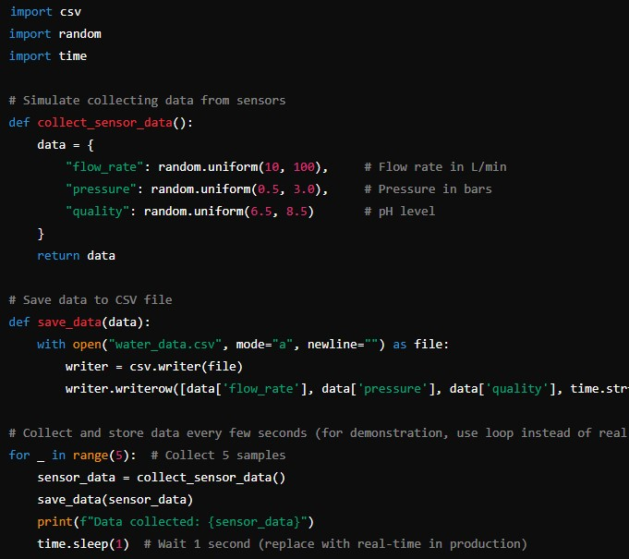

Load the data and apply a simple analysis to detect anomalies, such as a sudden drop in pressure that could indicate a leak.

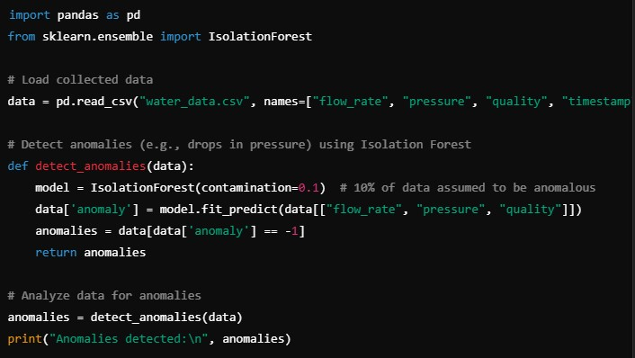

Using the analysis, control actions are taken—such as adjusting flow rates or sending alerts..

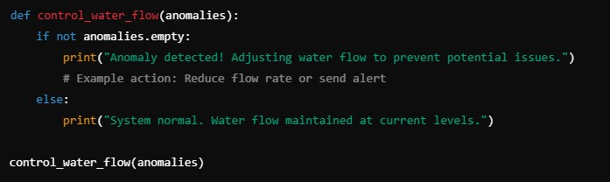

A simple real-time plot could help monitor water usage and anomalies visually. Here’s a basic plot for water quality over time.

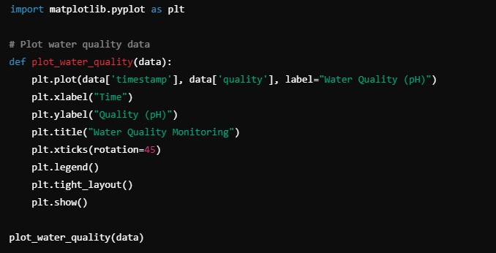

**Git Hub Link of the Project:** [**https://github.com/Shekfarish/Naan-mudhalvan.git**](https://github.com/Shekfarish/Naan-mudhalvan.git)

**Video Recording of Project:** [**https://drive.google.com/file/d/1-TN-8VL_mAHTVcLqH6Fc32IXWt4t84Qr/view?usp=drivesdk**](https://drive.google.com/file/d/1-TN-8VL_mAHTVcLqH6Fc32IXWt4t84Qr/view?usp=drivesdk)

**CHAPTER 5**

# Discussion and Conclusion

This project successfully demonstrates an innovative approach to efficient water management by leveraging AI, IoT, and automation technologies. By collecting real-time data from sensors, applying AI algorithms to analyze and predict water usage, and enabling automated controls, this system can effectively reduce water waste, detect leaks, and optimize water distribution.

The AI-Integrated Smart Water Management System not only addresses pressing issues in water scarcity and resource management but also offers a scalable, flexible solution adaptable to various settings, from urban areas to agricultural lands. With capabilities for real-time monitoring, anomaly detection, and user engagement, this system empowers users and managers alike to make informed, data-driven decisions. Ultimately, the project supports the goal of sustainable water use, contributing to both environmental conservation and economic savings. This approach showcases a practical and impactful way to leverage technology for one of the world’s most critical resources—water.